MŠICE (skutečná velikost cca 4 mm)
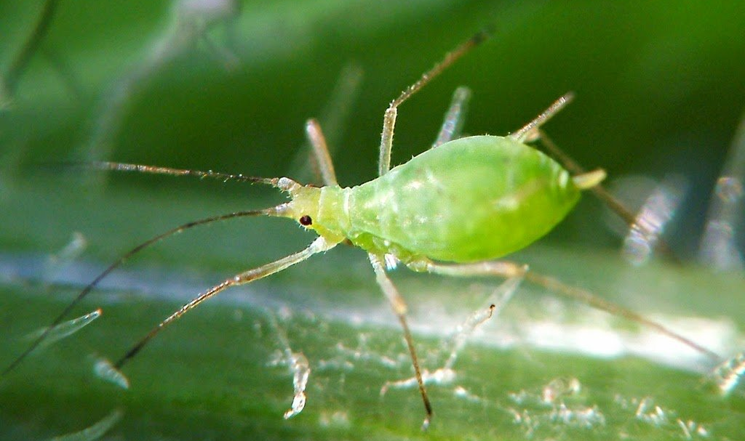
https://cultivers.es/wp-content/uploads/2021/09/pulgones-bacteria.jpg

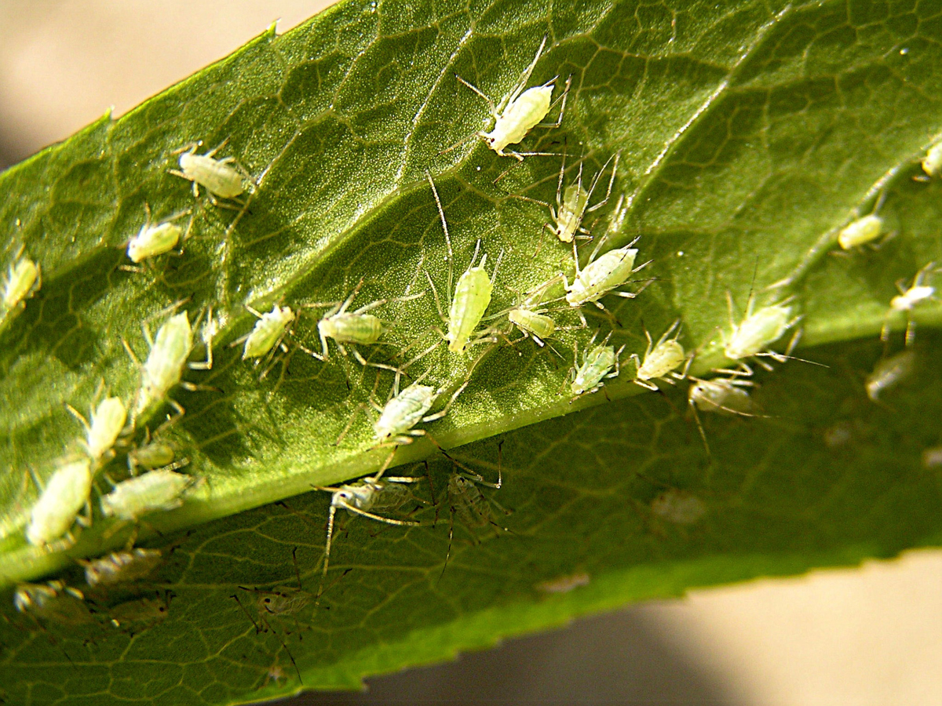
https://agrobio.cz/i/lg/files/fotky-poradenstvi/001126-050-okrasne-rostliny-msice-na-spodni-strane-listu.jpg

