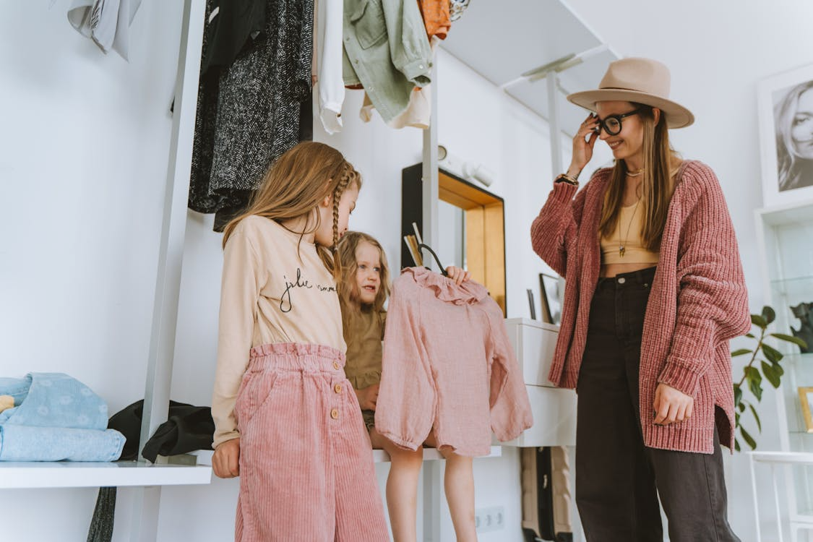
dedenie oblečenia

https://images.pexels.com/photos/8083846/pexels-photo-8083846.jpeg

