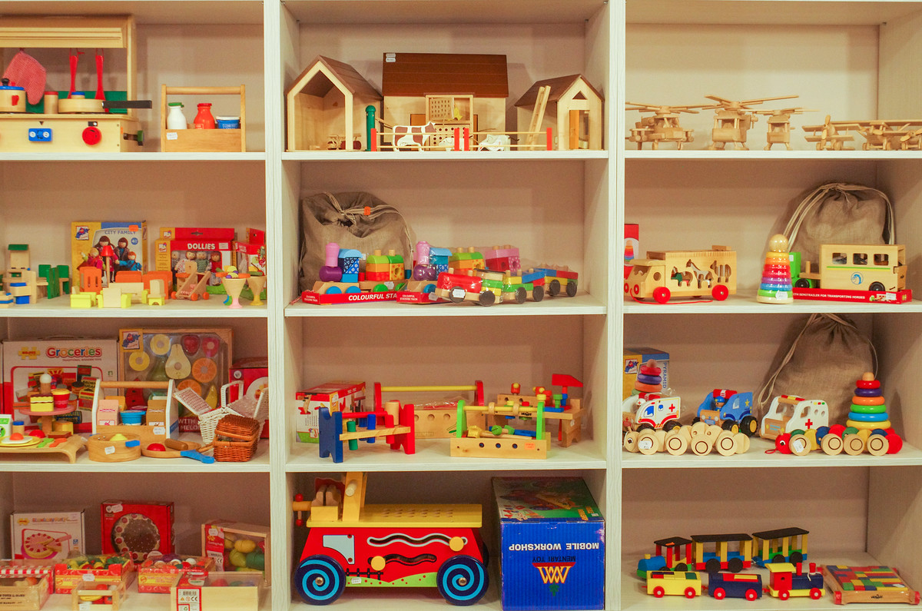

httpswww.olomouc.czzpravyclanekDrevene-hracky-Pinocchio-25086

