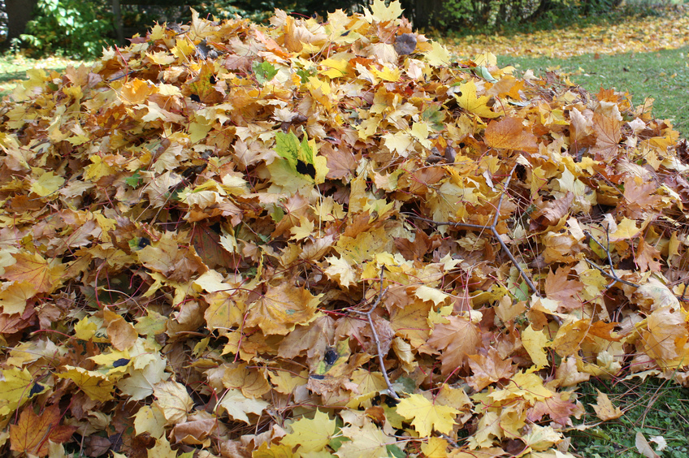 https://aa.ecn.cz/img_upload/e6ffb6c50bc1424ab10ecf09e063cd63/hromadalisti.jpg

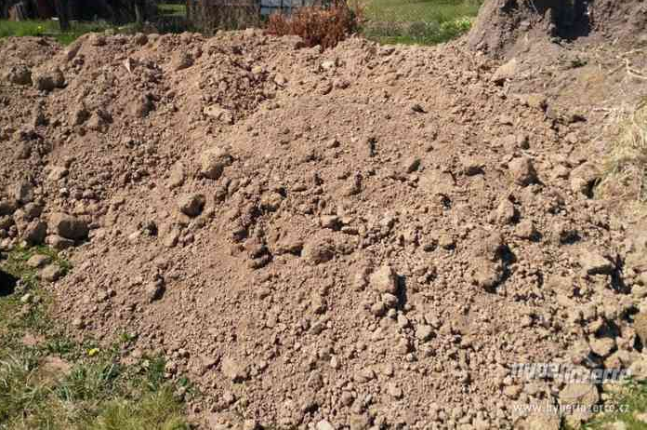https://images.hyperinzerce.cz/inzeraty/41531279529466938436%2Fthumbnail%2F15501251-zemina-hlina-001.jpg
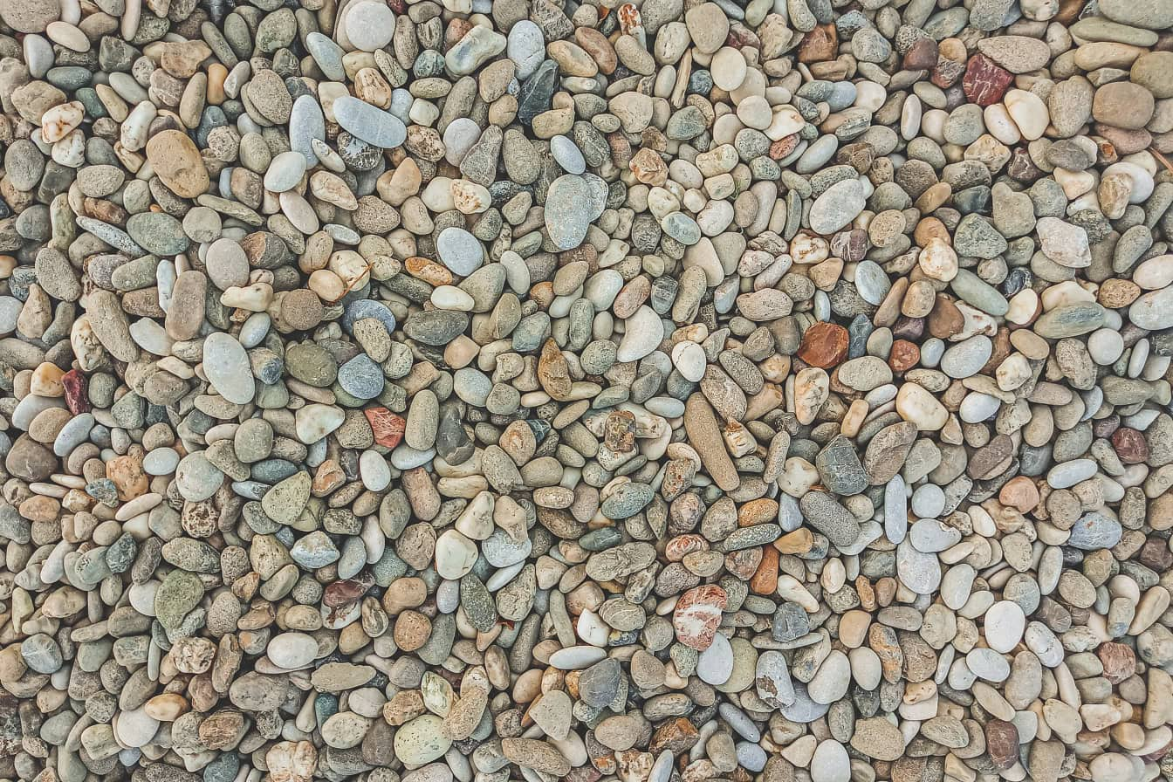https://pixnio.com/free-images/2024/08/14/2024-08-14-04-40-00-1344x896.jpg

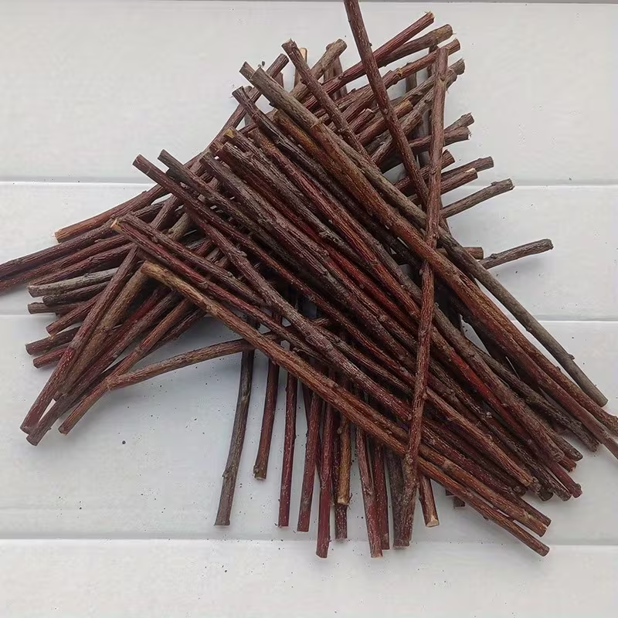 https://encrypted-tbn2.gstatic.com/shopping?q=tbn:ANd9GcQpAesduO-LlhdntHRJvupNCPQfB5tpZVrrkWefgymRJwqJGKAaI8VB-_txnz6_W1isgfirM_aMojxnZk_r5Qk_fZ4G810tfysCjMiOTOa4&usqp=CAc

