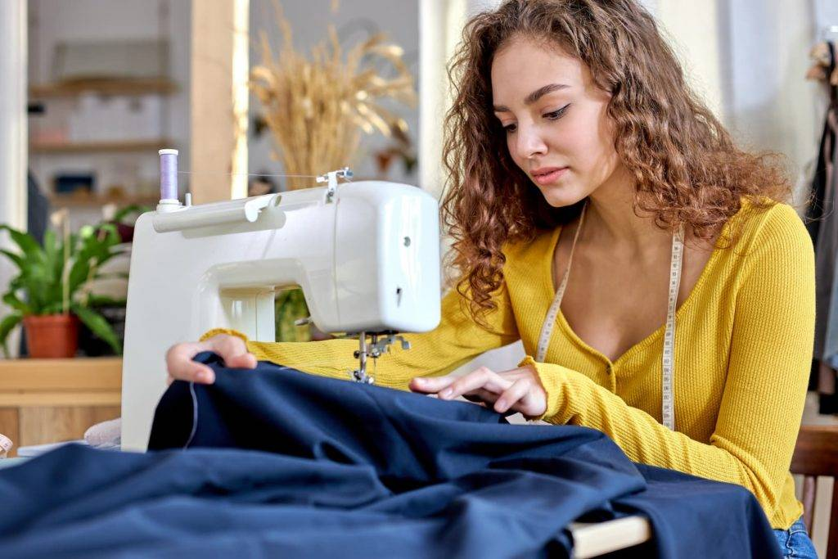
prešívanie oblečenia

https://cliffordssewingmachines.co.uk/wp-content/uploads/2024/08/AdobeStock_414540693-1024x683.jpg

