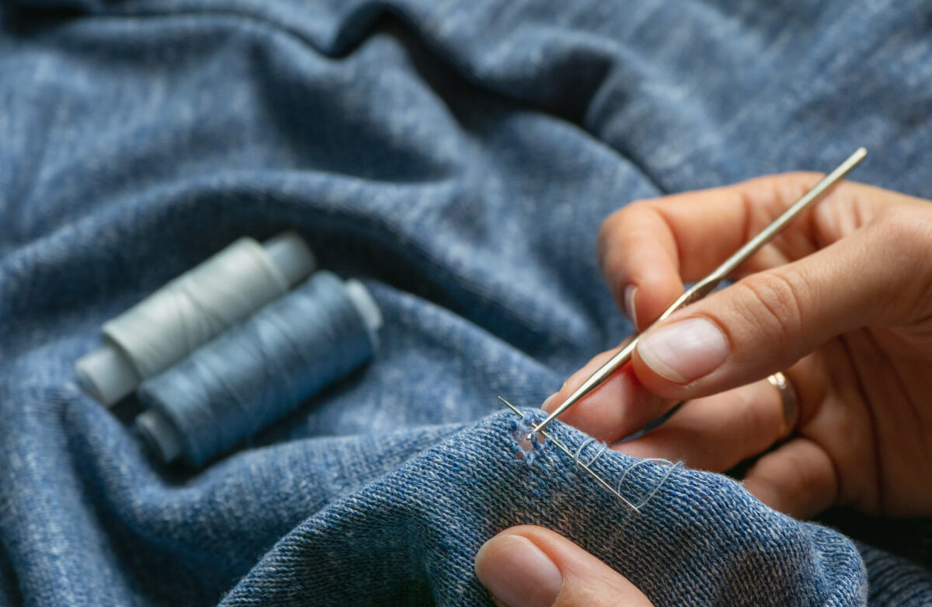
zašívánie oblečenia

https://www.bobvila.com/wp-content/uploads/2022/01/Sewing-Hole-in-Sweater-e1642609916661.jpg?quality=85&w=1200

